**Product: Social Stock Analyzer**

**Team:** Gurpinder Singh, Nout Reusken, Mihika Marathe, Ojas Upadhye, Qiuxia Tang

**Sprint Completion Date:** 02/22/22

**Revision Number:** 3

**Revision Date:** 3/5/22

**Goal:**

Users can add/remove stocks, search stocks and look at a basic analysis, and like/comment on stocks. Users can access the application from any computer.

**Task Listing:**

* As a user, I should be able to add and remove stocks from my portfolio as I choose so I can maintain the portfolio of my choice (3)
  + SS-40: Add/remove button on portfolio page and connect with back end. - Qiuxia (3hrs)
  + Check Alpaca API if available, checkbox with current stock. - Qiuxia (1hr)
* As a user I should be able to like and comment on a stock to voice my preferences/predictions so that I can engage with other users.(7)
  + Set up a stock database to hold each interacted stock. - Ojas(1hr)
    - Each row should store comments/likes associated with stock.
  + Set up a backend to fetch and post likes/comments. - Ojas(6hrs)
  + Set up the front end to show likes/comments for each searched stock. - Mihika (1)
* As a user, when I search up a stock I should be able to add it to my portfolio and see the social engagement on that stock.- Nout (5)
  + Retrieve and display stock information from Alpacas in form of statistics/graphs (3hrs)
  + Create an “Add Stock” button and connect with the back end. (1hr)
  + As a user I should be able to add a particular stock to my portfolio/watch list (1hr)
  + Create stock viewing component(1hr)
* As a user, I should be able to go to the stock viewer for stocks in my portfolio or likes section so that I can conveniently see the details of my preferred stocks. (3)
  + Link stocks on the portfolio to the stock view page(1hr).
* As a user I should be able to access the application over the internet so that I can access it on multiple devices without needing to download it. - Mihika (5)
  + Start migrating to AWS (2hrs)
* As a user, I should be able to see stock news on dashboard so that I can be up to date on current events related to my stocks and the stock market.(3) - Nout
  + Add new component to dashboard page(1hr)
* As a user, I should be able to get stocks that match a certain criteria. - Gurpinder (7)
  + Obtain and configure certain criteria for the user to personalize recommendations (2hrs)
  + Provide stock recommendations based on criteria. (5hrs)
* Tasks:
  + Sophisticated error messages. (0.5 hr)

**Spikes:**

* Look into migrating the application to AWS. - Mihika (3)

**Team Roles:**

Gurpinder Singh: Developer/Product Owner

Nout Reusken: Developer

Mihika Marathe: Developer

Ojas Upadhye: Scrum Master

Qiuxia Tang: Developer

**Initial Task Assignments**

Listed above.

**Initial Burnup Chart:** 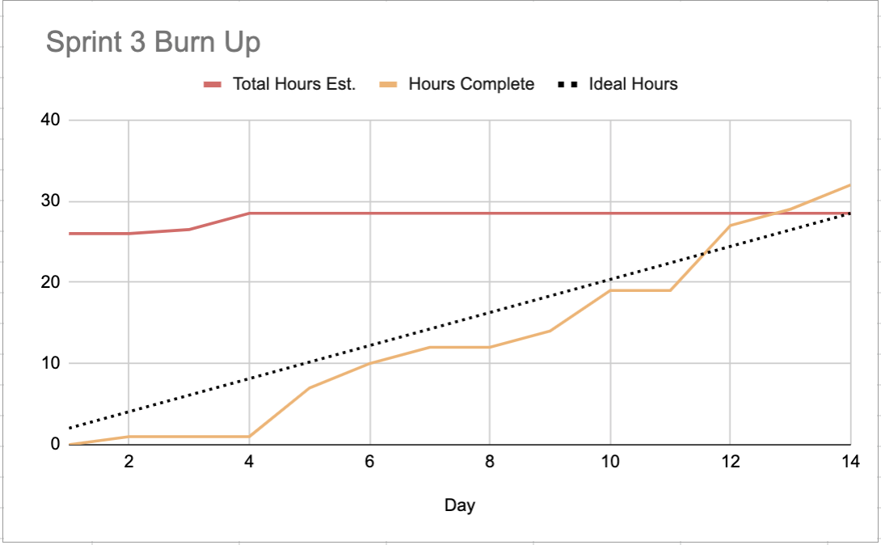

**Initial Scrum Board:** (task board, separate columns for tasks not started, tasks in progress, tasks completed)

*live version on Jira

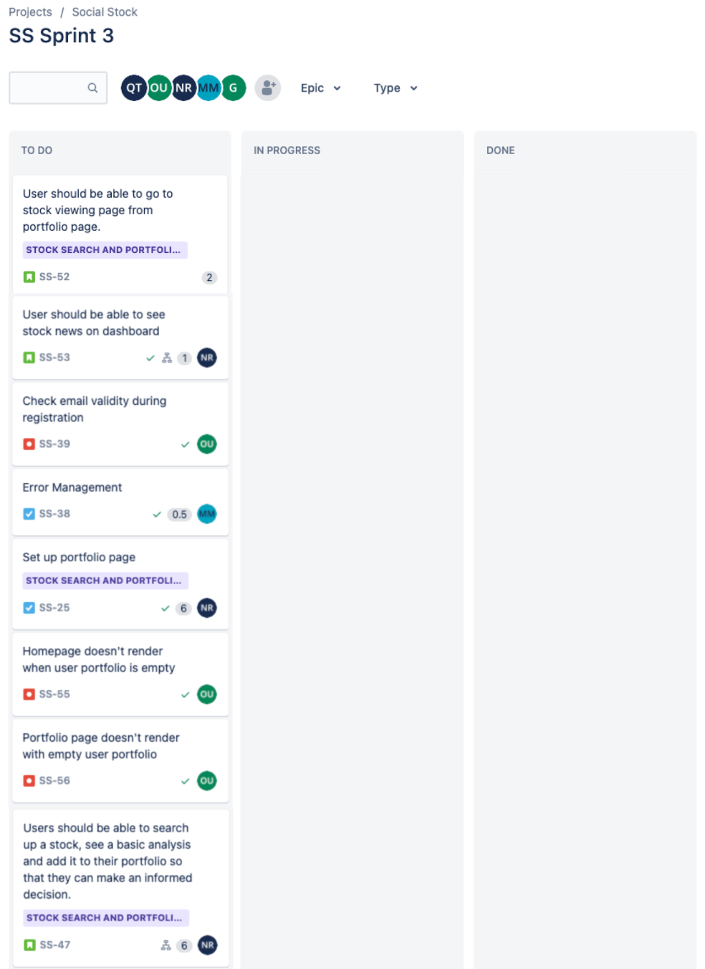

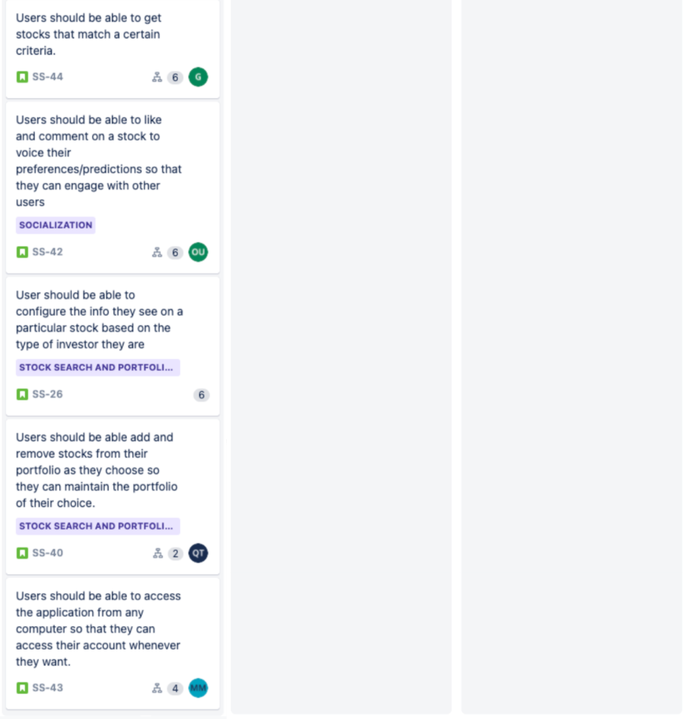

**Meeting Times:** (3 times that the team meets every week including the daily stand-ups, including one with the TA)

1. Friday 4:30-5:15 PM PST, meeting with TA

<https://zoom.us/j/8572731488?pwd=VTI2WTRIbEhqU3dtL3NNMGZTWldBZz09>

1. Tuesday 5:00 PM PST
2. Sunday 4:00 PM PST